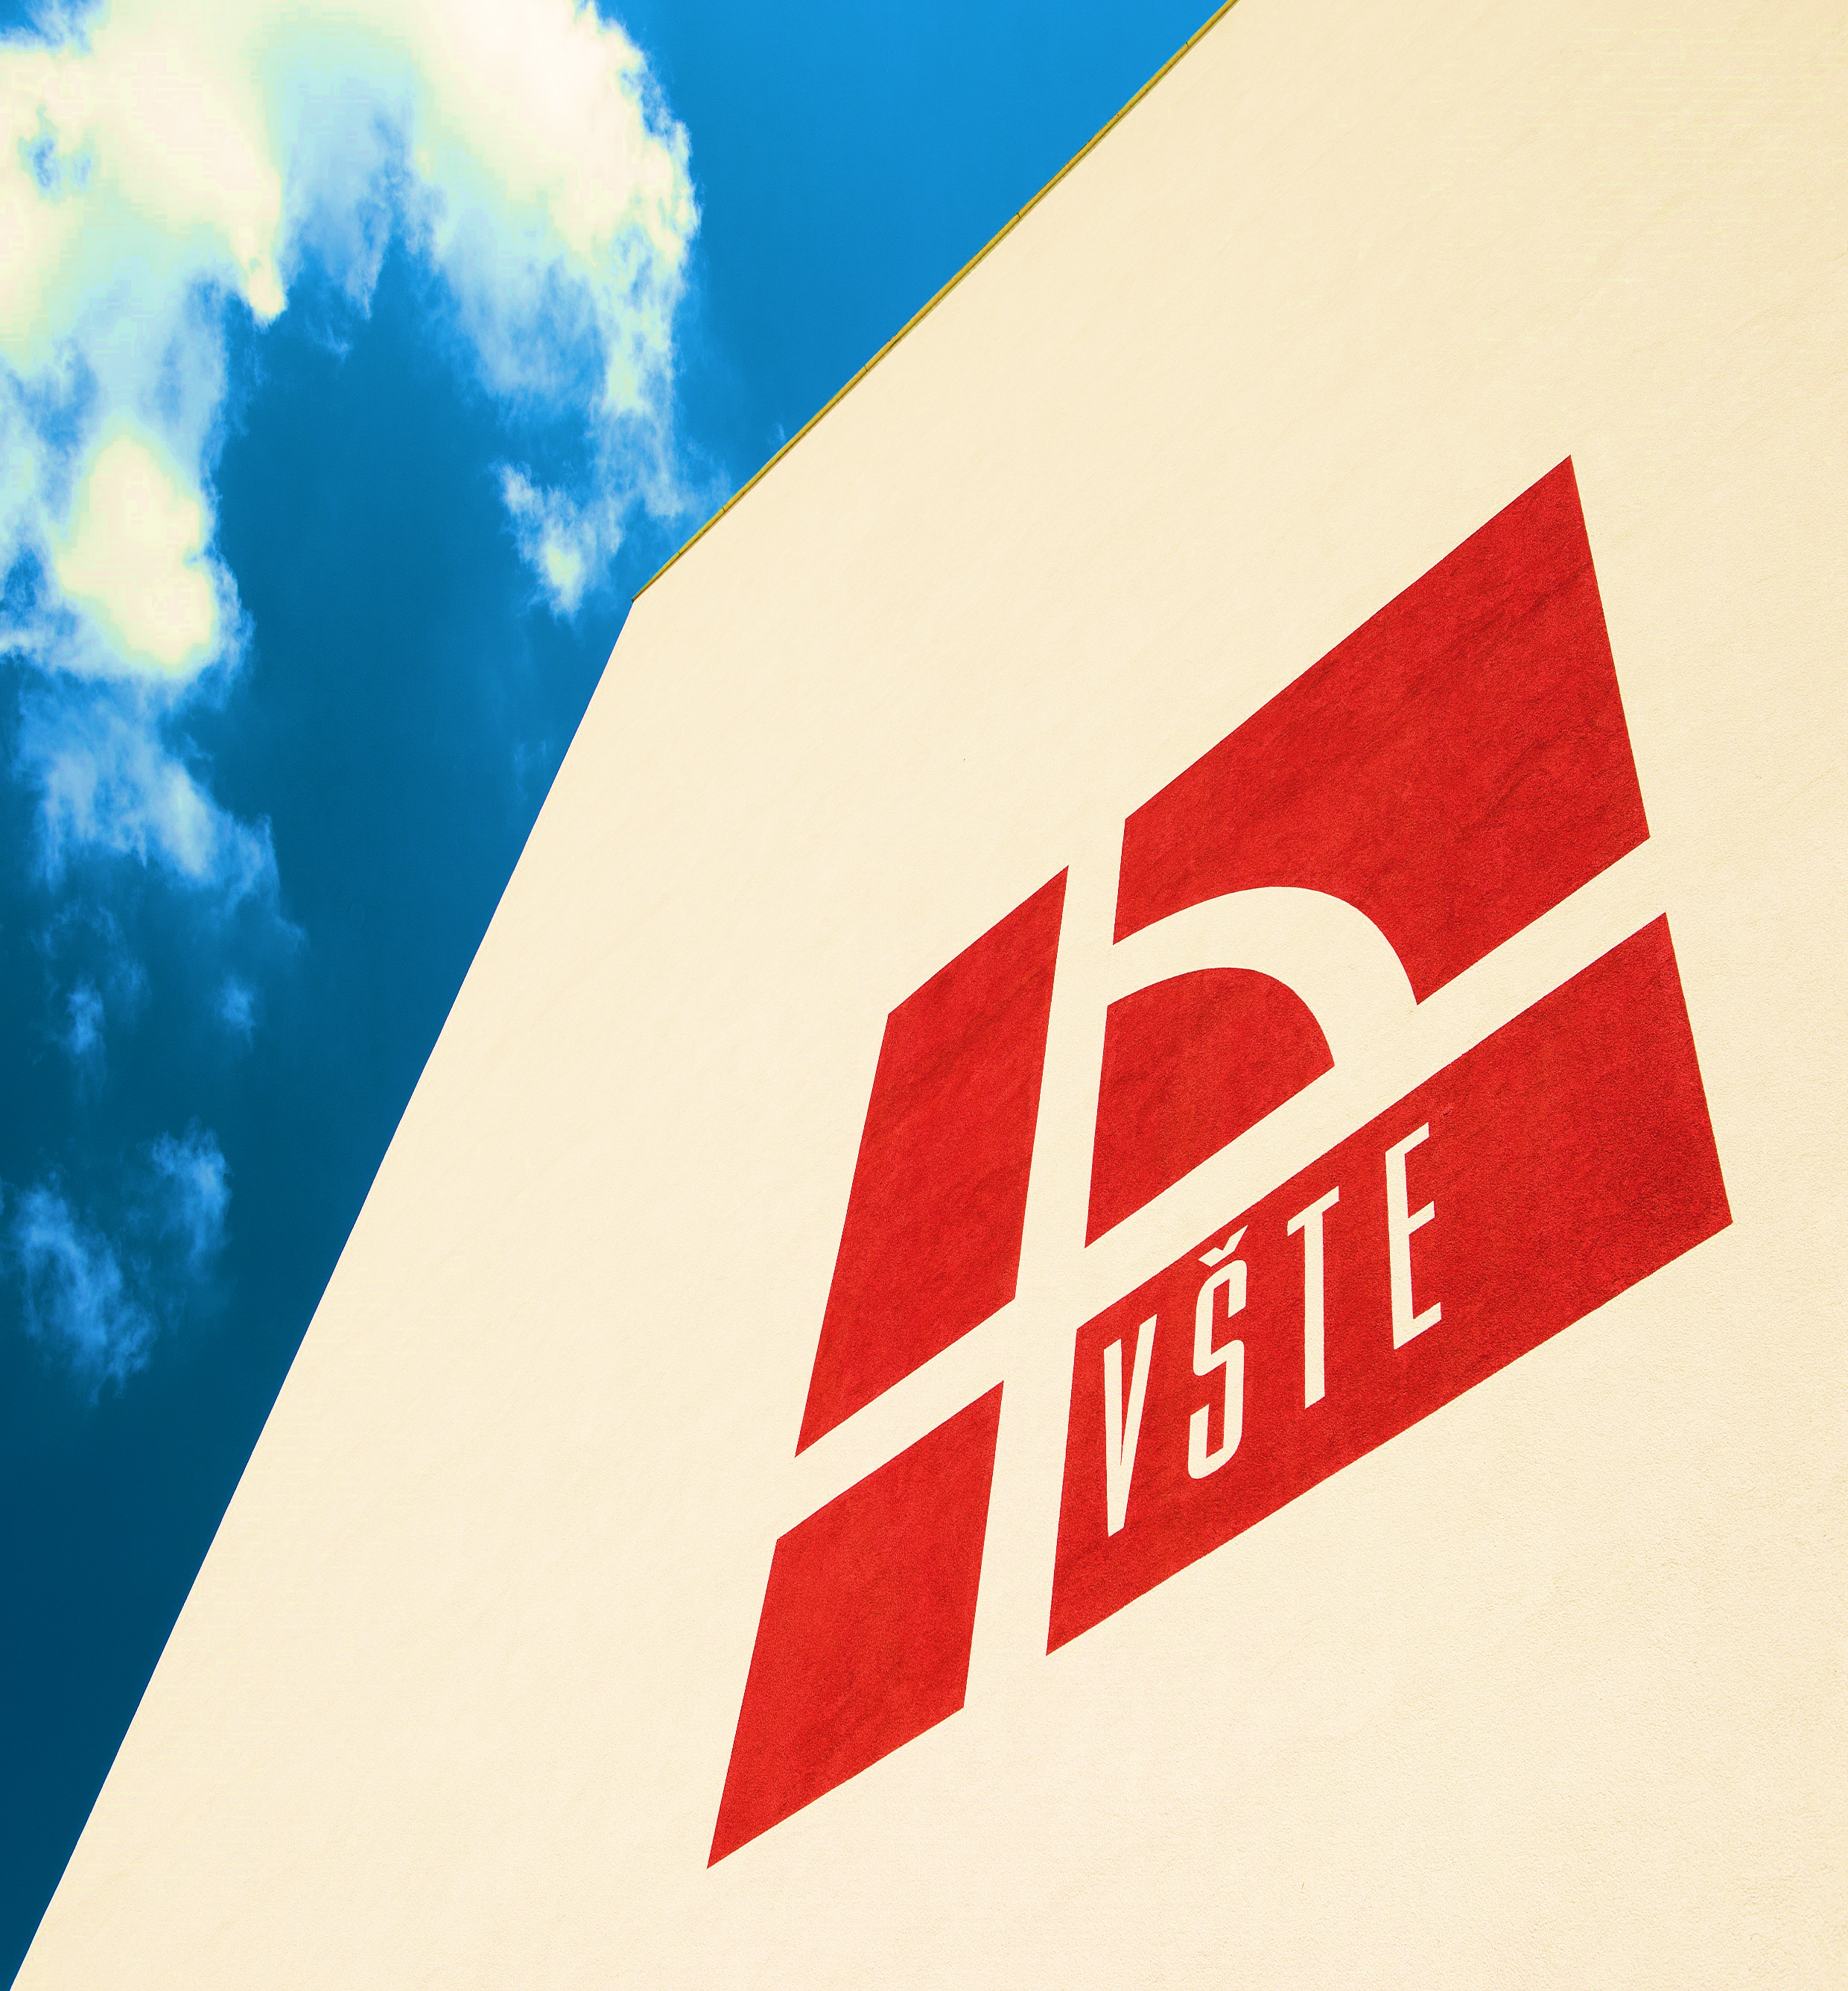
1. Gold Pack (All in One) – all services. Maximum possible care and help for students.

- Visa 250$ / 200€
- Nostrification 150$ / 120€
- Transport from Prague to Č. Budějovice 50$ / 40€
- Accommodation – single room 875$/ 700 €/semester
- Free Wi-Fi
- Studies 1750$/ 1400 €/semester
- Meals in VSTE refectory - (lunch) 225$/ 180€/semester
+ breakfast and dinners possible
The whole pack – 3300 $/ 2640 €/semester
When ordering Gold Pack, you will get Buddy program as a bonus and trips and excursions in the South Bohemian region with Czech students (within ESN)
2. Combined Pack – service pack prepared by the student on their own choice.
- Visa 250$ / 200€
- Nostrification 150$ / 120€
- Transport from Prague to Č. Budějovice 50$ / 40€
- Accommodation – single room 875$/ 700 €/semester
- Free Wi-Fi
- Studies 1750$/ 1400 € /semester
- Meals in VSTE refectory - (lunch) 225$/ 180€ /semester
+ breakfast and dinners possible

3. Minimum Pack – minimum number of services. It can be changed later.

- Accommodation – single room 875$/ 700 €/semester
- Studies 1750$/ 1400 €/semester
- Free Wi-Fi

Price of the pack – 2625 $ / 2100 €/semester
Preparatory language courses:
English language (20 lessons / week) + Czech language and Life and Institutions (2 lessons / week) 1750 $ / 1400 € / semester
Czech language and Life and Institutions (20 lessons / week) + English language (2 lessons / week) 1750 $ / 1400 € / semester

*All prices are estimated with 20 CZK/ 1$ and 25 CZK/ 1 €, that may vary due to exchange rate.
** All fees need to be paid in CZK.

